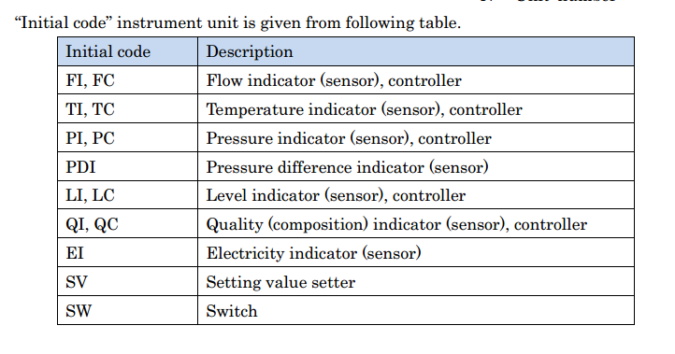
- MAL 15 Fail Absorber Circulation Pump
When this malfunction occurs, the P430 absorber circulation pump P430 is stopped and the circulation is stopped as well. Since the circulation has stopped, it is the absorption rate goes down. As less gas is absorbed, there are more gases to be pumped back to raw material feed for recycling use and less yield overall.
- Mal 16 Fail Buffer Tank Outlet Pump
The outlet pump stops work. Basically, there is no flow from the tank to the next stage. And the buffer tank is filled after a certain amount of time. All processes after buffer tank are stopped because of lack of feed. Yield goes to zero.

- Mal 17 Fail Column Bottom Pump
The column bottom pump stops working. It causes the distillation column stops working completely since the recycle acetic acid cannot flow due to pressure difference. Yield goes to zero since no output from column

The VAM plant is a simulation that models the process producing VAM (CH2=CHOCOCH3). The main reaction is
$$C_{2}H_{4}+CH_{3}COOH+\frac{1}{2}O_{2}→CH_{2}=CHOCOCH_{3}+H_{2}O$$
And the side reaction is:
$$C_{2}H_{4}+3O_{2}→2CO_{2}+2H_{2}O$$
The plant has been set in a way that effectively recycles unused reactants and includes multiple feedback control.
Initially, the raw materials, $C_{2}H_{4}$ (gas)and acetic acid (liquid), are together feed to a steam driven vaporizer so that the acetic acid is vaporized. Since the main reaction requires a temperature over room temperature, the mixed vapor is feed to a reactor preheater to increase the reaction rate later. After preheater, there is an emergency N₂ purge connected to the output of preheater. And the C₂H₄ and acetic acid gas mixture is further mixed with oxygen before feed to reactor.
The chemical reaction happens in reactor and the gas phase products, desired and undesired alike, are feed to a cooler first and then on the way to the separator. The still-gas cooled products mixture is sent to another cooler which turns gas phase products into a gas-liquid mixture before it reaches separator. In the separator, the liquid and gas are separated. On one hand, the gas is send to an absorber after being compressed. On¹⁵ the other hand, the liquid is sent to a buffer tank.
For the gas phase product, it is feed to the absorber where recycled acetic acid is feed to the absorber at the same time. Acetic acid will absorb desired product. Acetic acid with absorbed product is mixed with liquid output from separator and goes to the buffer tank. The unabsorbed gas is feed back to the raw material feed pipe after being cooled. Buffer tank stores incoming liquid until a certain level, liquid in it is feed to column. In the column the products are purified and cooled. The liquid is send to recycle and the gas phase product is sent to decanter. In the decanter, the VAM is separated from water. And we get our final product.

